# JWTValidationStep

**Objective:**

It is used to check the authentication and validations

**Attributes:**

|  |  |
| --- | --- |
| **Attributes** | **Description** |
| sourceExpression | Used to get the token, it is a key value pair |
| output_variable | Used to store the response of the request |
| value_type | To select type as free marker template or handlebar |
| name | To enter the name, it is an optional field |
| plugin_name | To connect with jwt based on signKey |

**Sample config.json:**

{

"workflows": [

{

"name": "jwt-validate",

"id": 200,

"trigger": "rest",

"expression": "jwtvalidate",

"method": "GET",

"steps": [

{

"type": "start",

"id": 1,

"next": {

"start": "start"

}

},

{

"subject": "claims",

"claims": [

{

"key": "header1",

"value": "handler"

},

{

"key": "header2",

"value": "value"

}

],

"output_variable": "jwtOutput",

"plugin_name": "jwt-validate",

"value_type": "hb",

"type": "jwt",

"id": "start",

"next": {

"success": "jwt-success",

"failure": "hangup"

}

},

{

"name": "claims",

"sourceExpression": [

{

"key": "jwt-token",

"value": "{{{jwtOutput}}}"

}

],

"output_variable": "jwt-validateOutput",

"plugin_name": "jwt-validate",

"value_type": "hb",

"type": "jwt-validate",

"id": "jwt-success",

"next": {

"success": "jwt-validate-success",

"failure": "hangup"

}

},

{

"variable_name": "jwt-validateOutput",

"http_response_code": "200",

"response_content_type": "text/html",

"value_type": "hb",

"type": "send",

"id": "jwt-validate-success",

"next": {

"success": "hangup",

"failure": "hangup"

}

}

]

}

],

"filters": [],

"server": {},

"plugins": [

{

"id": 25,

"name": "jwt-validate",

"type": "jwt-plugin",

"version": "1.0",

"category": "jwt",

"signKey": "z0NN9huvOKW8Me8QSrREaG9BP4_7oG1PaKbs6wYlysY"

}

]

}

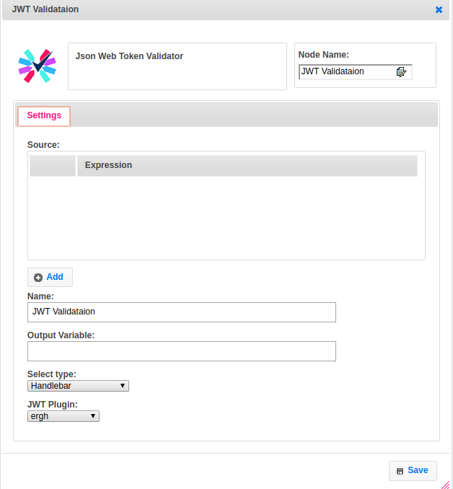

**Executor Description:**

* In executor class first will get jwt_sign_key from jwt plugin handler by passing signKey
* By parsing the source expression will get the token. If that token is valid then then it will return success otherwise it will throw jwt validation error exception. Using this step we can get claims of the JWT Token.